
Assisting System Personnel
In Keeping Current
N
E
R
C

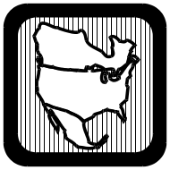

NERC

Training Document

Synchronizing Islands Overview

Developed by:

NERC Training Resource Working Group

July 17, 2002

NERC Training Reference

July 17, 2002

Subject: Synchronizing Islands

Overview 3
What You’ll Learn 3
References 3
Training Time 3
Synchronizing Islands Introduction 3
Basic Conditions 4
Synchronizing Locations 4
Specific Synchronizing Issues 4
Synchroscope Operation 5
Matching Voltages 7
Matching Frequency 8
Synch-Check Relay (25) 10
Electronic Automated Relays 11
Auto Synch Relay & Scope 11
Acronyms, Terms and Definitions 12
Review Questions 13

Overview
This document provides an overview of the concepts involving synchronizing islands after a widespread blackout or system separation. The goal is to build the understanding of basic concepts and knowledge to perform the task of synchronizing islands.

Suggestions for improvement of this reference can be sent to the NERC Training Resource Working Group.

What You’ll Learn
When you complete this lesson, you should:
- Understand the equipment necessary to synchronize islands
- Understand the issues involved in synchronizing islands
- Know where this equipment is installed on your system
- Understand the basic concepts involved in directing synchronizing procedures or operating synchronizing equipment

References
NERC Policy 5, System Restoration
NERC Policy 6 System Restoration
NERC Electric System Restoration Reference Document
NERC Regional Councils
IEEE Std C37.2-1996 - Description
Your Regional Black/Start Restoration Plan
Your Company Black/Start Restoration Plan
Internet simulation of a synch panel

Training Time
Estimated training time for this lesson is 1-2 hours.

Synchronizing Islands Introduction

When a widespread blackout or system separation occurs, the system operator often must restore the power system utilizing small islands. Typically, the restoration process requires “Black Start” generators to form small islands. Each island is expanded until it becomes necessary or desirable to connect to other islands. The sooner small islands are interconnected, the better they can withstand any additional disturbances. The process of connecting and independent islands involves synchronizing. This lesson is an overview of the fundamentals.

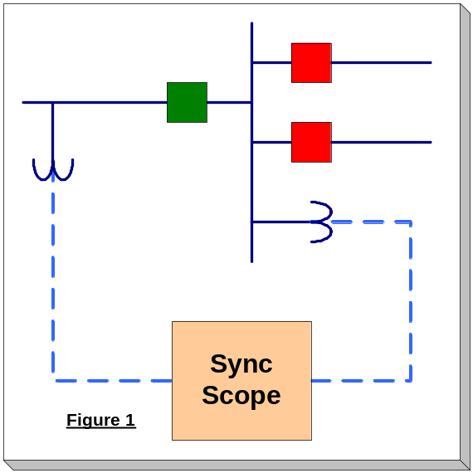Basic Conditions

Several conditions must be met before two islands can be reconnected or synchronized. These conditions are measured at the point of reconnection. (Figure 1) The circuit breaker used to reconnect the islands must have synchronizing equipment in place and operable. This equipment could be permanently installed or it could be portable.

Synchronizing Locations

Synchronizing locations on your particular system must be known. Pre-planning is a necessity. Usually they can be found in your company’s Black Start/Restoration Plan, on system maps, or in other operating documentation used in your office. Synchroscopes and/or synchronizing relays can generally be found at interconnection substations and generating plant substations and can vary from system to system. It is important to familiarize yourself with these locations. You should also familiarize yourself with the specific type of synchronizing equipment at each location. More information on the types of equipment will follow in this document.

Specific Synchronizing Issues

At the circuit breaker, where islands will be synchronized, the following four conditions should be considered:

- The voltage magnitudes of the two systems must be matched as close as possible.
- The frequencies of the two systems must be close to identical.
- The voltage phase angle between the two systems must be within allowable tolerance levels, as defined by the system engineers for the specific area where the synchronizing will occur.
- You must recognize that field-switching employees may not be familiar or well trained in synchronizing operations.
Operating Tip: The goal in synchronizing two systems is to match frequency (speed) and phase angle so that there will be little or no transfer of energy between the two systems when the breaker is closed.

Synchroscope Operation

The most common and oldest method of synchronizing two systems is to use a manual synchroscope (See the following figure and schematic drawing). Typically, there is an interlock associated with circuit breakers at synchronizing points. Before manually closing a circuit breaker, the operator is required to enable the synchroscope. This allows the operator to visually observe the phase angle difference across a breaker as well as monitor the rate of frequency-slip (rotational difference between two systems), if frequency-slip exists. The operator would then decide if and when to close the breaker. The synch-switch (synch-key) contact only supervises local (manual) control of the circuit breaker and switches the voltage inputs (Figure 5) to the synchroscope for the synchronizing circuit breaker. The operator performing this operation must be familiar with this equipment or be able to quickly learn while working with the system operator.

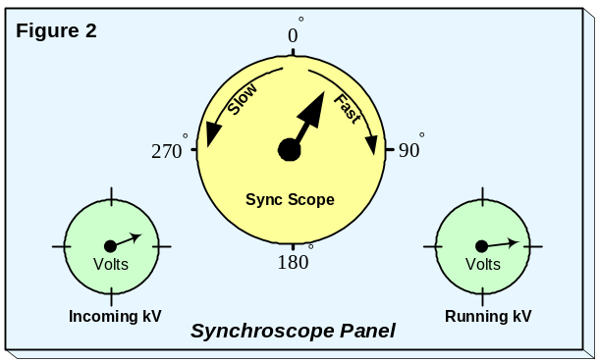

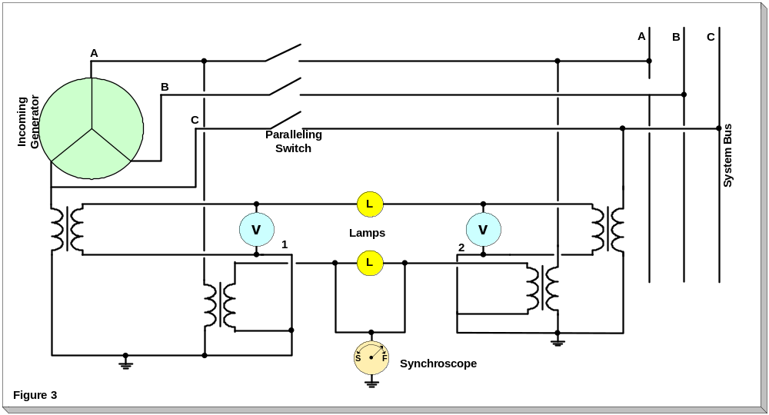
Schematic drawing of a typical Synchroscope

Because of the importance of synchronizing, a review is in order. Recall that a synchroscope measures the phase angle difference of the voltage across a circuit breaker.
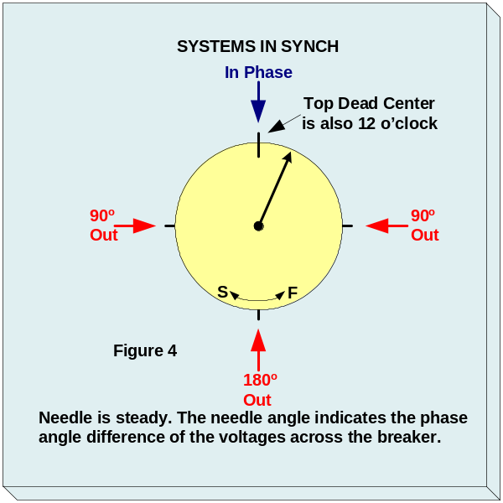
When using or directing the use of a synchroscope, the first consideration involves the speed of needle rotation and the direction of rotation. The direction of rotation indicates which system is faster than the other. This is important from the standpoint of directing the power plant operator of the island selected to control frequency to speed up or slow down. The speed of rotation is also important. A needle rotation of one or less revolutions for a five-second interval is good control.

When the synchroscope needle is steady (Figure 4), the speed (frequency) of the two systems is matched. Thus, any needle deviation (from top dead center) indicates the phase angle difference of the voltages across the open circuit breaker. Top dead center indicates a zero phase angle, (voltage phase angles are matched). If the rotation of the needle is fast, the next step is adjusting the frequency is one system (either running or incoming – Figure 5) in such a direction to slow the needle rotation sufficiently to allow the operator to anticipate closing the circuit breaker when the needle reaches top dead center.

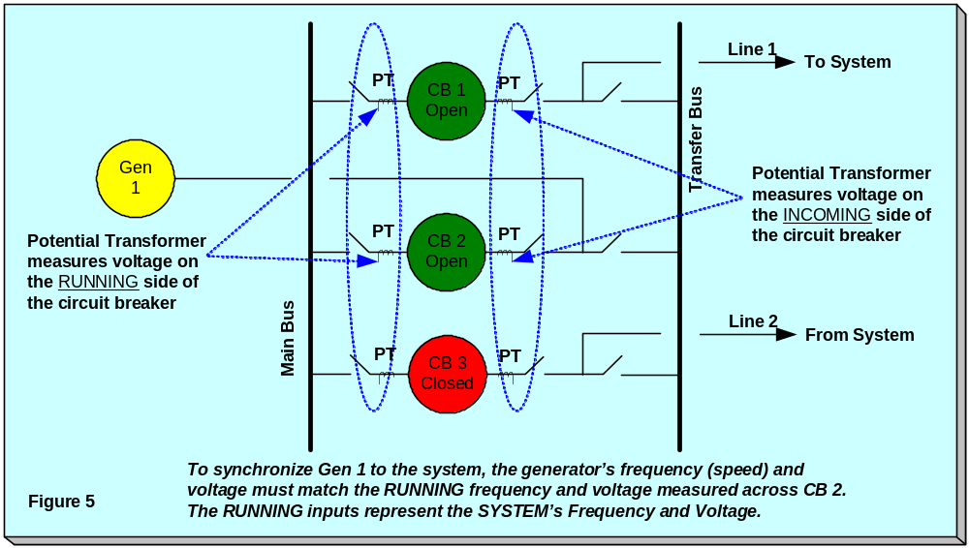 Some synchroscopes may be marked in minutes, instead of degrees. You must use caution when directing field-switching personnel when discussing the phase angle indicated on the synchroscope. A synchroscope needle that is pointing at 10-minutes from top dead center indicates that the two systems are 60-degrees out-of-phase, each minute (increment) represents 6-degrees. If your allowable phase angular difference is ± 20-degrees, then the synchroscope needle must be approximately 3-minutes from top dead center to close the circuit breaker.

Synchroscopes will usually be equipped with indicating lamps. The use of these lamps is to check the rotation of the synchroscope for accuracy. The indicating lamps are typically connected such that they are dimmest when the two systems are in phase (and the synchroscope is therefore at 12 o’clock). The local operator should verify that the lights dim each time the synchroscope needle passes through top dead center.

NOTE: Lamps can be wired to be either a full brilliance or dark when an in-phase condition is present. Frequency differences between the two islands greater than 3.5 Hz will cause the lamps to flicker rapidly. Reliance, solely on the indicating needle is not recommended without checking against the indicating lamps.

Note: Beware if the field-switching employee reports a vibrating synchroscope needle! The systems may be so out-of-phase that the needle does not rotate but rather just vibrates.

Matching Voltages

The voltage magnitudes on the two sides of the circuit breaker should be as close as possible to one another. The greater the voltage difference translates into a greater reactive power (MVAr) that will flow when the breaker is closed. The large MVAr flow can cause sudden changes in voltage and cause protective relays to operate.

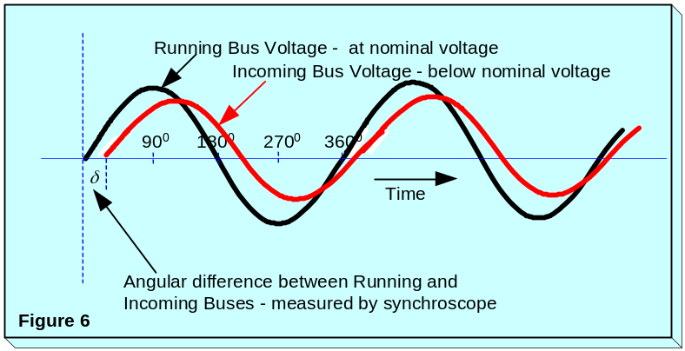A large MVAr surge can cause undesirable relay operations and cause problems at nearby generation stations. Ideally, the voltage magnitudes will be identical, however, this is not always possible. A rule of thumb would be to close the circuit breaker with no more than 2-5% voltage difference between the two islands. A recommended place for a synchronizing location would be at a generation station. A plant operator is generally better trained in synchronizing and has direct control of voltage. Keep in mind that a plant operator may have concerns for plant auxiliary voltages, so some other remote means of adjusting voltage may also be necessary.

Station voltage meters are usually identified with the terms “incoming kV” and “running kV”. If synchronizing at a plant, the plant side of the circuit breaker would be the running bus. The external system side of the breaker would be incoming value. Refer to Figure 6. Notice the difference in nominal values. The difference translates into a reactive power (MVAr) flow if the breaker is closed.
Operating Tip: Synchronize at a generation plant when possible. A plant operator is usually well trained and voltage control is easier to accomplish.

Matching Frequency

The frequencies of two islands will likely be different because the generation for each island being independently controlled. Before the circuit breaker can be closed the frequencies must be very close together and “in phase”. Think of a mechanical transmission that is about to lock two large machines together. The two gears that are to be meshed must be operating at the same speed and also the teeth must be aligned. The same concept is true when synchronizing islands.

Not only do we have to take into account the frequency mismatch between two islands but also the ability of the field operator to anticipate the circuit breaker’s “closing speed” when the synchroscope needle reaches top dead center. Again, mismatched frequencies will cause a large power flow across the circuit breaker when it is closed. When the circuit breaker is closed, the two systems will attempt to lock in step and establish a common frequency. The allowable difference in frequencies before closing the circuit breaker is system and equipment specific. Under normal conditions, the difference may be no greater than 0.05 Hz. Under abnormal conditions, a system may tolerate up to a 0.1 Hz frequency difference.

The synchroscope tells the operator the “rotational difference” between the two systems. A synchroscope rotating at one (1) revolution per second implies a 1 Hz difference between the two systems. A scope rotation at one (1) revolution per 10 seconds equates to a 0.1 Hz difference. The direction of rotation tells which system (incoming or running) is going faster. (Clockwise rotation means the incoming system is slower than the running system.)

Again, if the frequencies of the two systems are different, the voltage phase angle is constantly changing. Active power (MW) will flow from the system with the faster frequency and to the system with the lower. When frequencies are the same, the voltage phase angle is constant. No power will flow when the breaker is closed when the synchroscope reaches the “12 o’clock” position (the point when the two systems are exactly in phase).

An operator can adjust island frequency by controlling the generator speed changer (governor) and therefore the speed of the system. This process requires close coordination among the generator operator(s) controlling the throttles, the system operator directing the process and the field operator closing the circuit breaker.

As a review, refer to Figure 7. The top example indicates a mismatch in frequency greater than 0.1 HZ. A large power flow (MW) would occur when the circuit breaker is closed. The second diagram indicates a slight mismatch in frequency, which is acceptable when synchronizing islands.

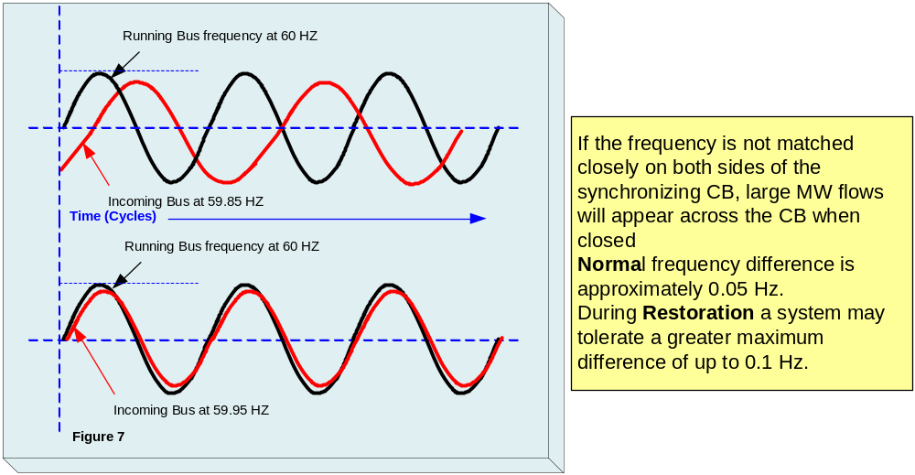

Using the power transfer formula, we can mathematically see the problem caused by mismatched voltages and phase angles.

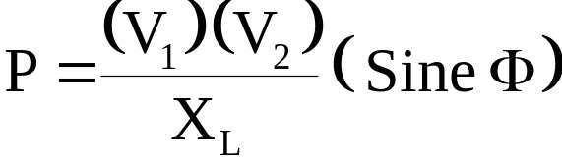
From the above formula you can see that given matched voltages (V₁ and V₂) and a fixed system reactance (X_{L}), the angle difference (Sine Φ) between two islands will have the greatest effect on the power transfer between the islands, as they pull each other into synchronism. The larger the phase angle difference (Sine Φ), the larger the power flow. A large power surge can cause undesirable relay operations and damage to nearby generators.

Because the two islands’ frequencies will vary independently, it is not advisable to “chase” a frequency match between the islands by constantly adjusting generator speeds in both islands. The frequency in the smaller island is easier to adjust if there is a need to manually adjust frequency. Make small incremental changes to the speed of a generator until the frequency matches the larger system. Wait for the synchronizing equipment (synchroscope) needle to slow and approach top dead center.
Operating Tip: Be patient and wait for a natural match between the two island’s frequencies and voltage phase angles.

Synch-Check Relay (25)
Note: An engineering shorthand number of 25 used in the electrical industry to describe a piece of equipment used for synchronizing or synchronism-check. 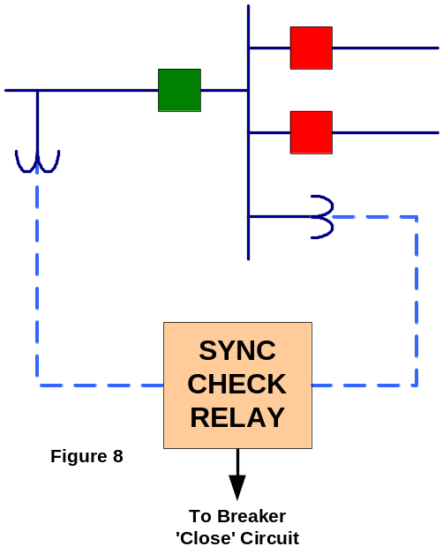The #25 is based on a system adopted as standard for automatic switchgear by the Institute of Electrical and Electronics Engineers, Inc. (IEEE) incorporated in American Standard C37.2-1996. This system is used in connection diagrams, instruction books, and in specifications.
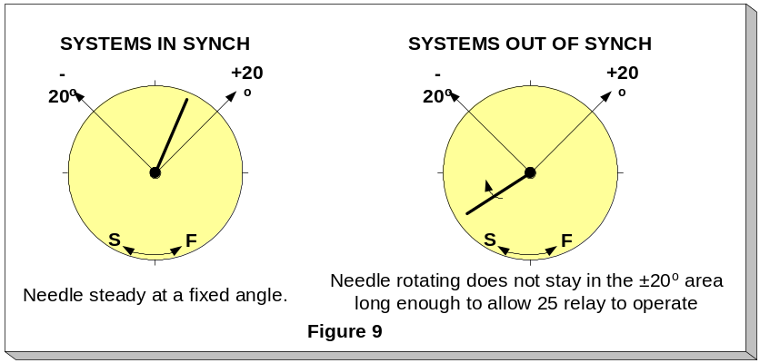The primary function of a synch-check relay is to prevent a circuit breaker from closing if the power angle is too large across the circuit breaker. A synch-check relay electrically determines if the difference in voltage magnitude, frequency and phase angle fall within set limits. The allowable differences are determined by engineers and will vary with location on the power system. Typically, the further away from generation and load, the more difference can be tolerated. (Your system may tolerate more or less angle due to its topography) The relay does not provide any display of information but decides internally whether the conditions for closing a circuit breaker are satisfied. Usually the angle across the breaker is less than 20 degrees. Keep in mind we are using 20 degrees as a example but the angle for any particular system or location may be different as determined by system engineers.

A synch-check relay determines (checks) that systems on each side of the breaker are in synchronism. It also requires the systems be within a set phase angle. (Typically ± 20 degrees)
Since the application and use of synch-check relays varies from system to system, we recommend additional training that is specific to your system.

The sync-check relay does not provide a visual indication of what is occurring between the systems, although the above graphical illustrations (Figure 9) gives you a visual image of the decision being made within the relay intelligence.

Operating Tip: Synch-check relays are usually used at lines leaving generating plants and on interconnections.

Electronic Automated Relay

This is also a newer electronic relay that monitors phase difference and rate of frequency-slip across an open breaker. It will allow a close if the frequency-slip rate and the phase difference is less than locally defined set points. The relay usually will monitor the local breaker control switch, Supervisory Control & Data Acquisition (SCADA) breaker control or other computer breaker controls. There will also be a local display of the phase difference at the computer-controlled substations.

Auto Synch Relay & Scope

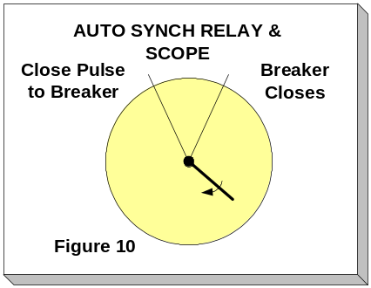 Another type of automatic relay used in some substations is the auto-synch relay (Figure 10). It is used mainly on generator breakers. It is more sophisticated than a synch check relay. The relay measures the speed and voltage of the generator against the system. It then gives raise/lower signals to the generator governor (speed) and voltage regulator to match the system. It then anticipates when the generator will be in exact synch with the system, taking into account speed differences and breaker closing time. This type of relay will generally not be useful to the operator when synchronizing islands. This discussion is included to make the operator aware of this type of relay and hopefully prevent confusion about its use in synchronizing.

Acronyms, Terms and Definitions
Device Number (25): A device number (25) is used to describe a synchronizing or synchronism-check device as adopted as standard for automatic switchgear by IEEE.

Synchronize: The process to bring two electrical systems together by closing a circuit breaker.

Sync Scope – Synchroscope: An instrument used to indicate a difference in frequency between two electrical systems.

Sync Relay: Similar function to a synchroscope but the relay has built in intelligence to perform automatic operations based on various electrical quantities.

HZ – Hertz: Hertz is the unit of frequency equal to one cycle per second.

MVAr – Megavolt Amp Reactance: A unit of reactive electrical power equal to the voltage times the amps times the sine of the angle between voltage and current.

MW – Megawatt: A unit of electrical power equal to one Watt times 1,000,000

NERC: North American Electric Reliability Council

Φ - Theta: A Greek symbol used to indicate an angular measurement.

IEEE: Institute of Electrical and Electronic Engineers

P – Formula Symbol: A symbol used to indicate electrical power.

V₁ – Formula Symbol: A symbol used to indicate the Voltage at a station bus designated as number 1.

V₂ – Formula Symbol: A symbol used to indicate the Voltage at a station bus designated as number 2.

X_{L} – Formula Symbol: A symbol used to indicate the Inductive Reactance of a transmission line. This reactance provides opposition to the flow of alternating current.

SCADA – Supervisory Control and Data Acquisition: The system used by electrical utilities to gather power system information and control substation and other equipment remotely.

Review Questions
- Following is a simple power flow equation:

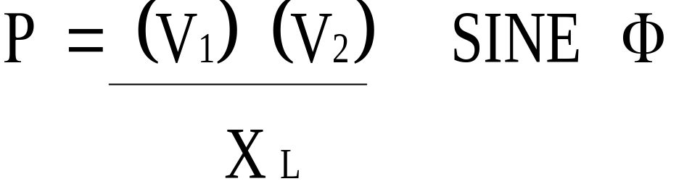
What is the preferred value of Sine “” when synchronizing islands?
- + 20 degrees
- Twelve o’clock
- Zero degrees
- – 20 degrees

- You are attempting to connect two systems (or islands) together using a typically wired synchroscope. When the synchroscope is turned on the needle is pointing straight down (not moving) and the lamps are full brilliance. What does this indicate?

  - A 3.5 Hz frequency difference between systems, and a minimum voltage angle
  - The systems are out of phase by 90 degrees
  - The systems are out of phase by 180 degrees
  - The frequencies are matched, but the voltage angle difference is maximum

- Use the same conditions as Question 2. What would you do to synchronize the two systems?

  - Turn off the synchroscope and try again later.
  - Order the small system to change frequency slightly.
  - Synchronize at some other location
  - Close the circuit breaker

- When closing a circuit breaker between two systems (or islands) through a sync-check relay, the circuit breaker will close when:

  - The two systems are exactly in phase.
  - The two systems are within 10-minutes of top dead center.
  - The two systems are within the relay’s settings.
  - The two systems have a 0.05 Hz frequency difference.

- What is the basic advantage of an “auto sync” relay over that of a synch-check relay?

  - There is no difference because the relays are identical.
  - An auto sync relay will adjust the speed of a generator along with comparing voltage and phase angle.
  - The synch-check relay requires a field operator present.
  - The auto sync relay is fail proof.

- Which of the following is the best choice to be used to sync a large generator on line?

  - Auto sync system
  - Synchroscope
  - Synch-check relay
  - Phase rotation relay

- During restoration of your system you have created two large islands. You are ready to connect them together, but there is no synchronizing equipment available at the existing open points. What should you do?

  - Restructure the islands so that sync equipment is available at an open point.
  - Have a switchman go to substation and check voltages in each system. If they are nearly the same, connect systems.
  - Change frequency in one of the systems.
  - It just doesn’t matter, close breaker – the system should be able to handle it.

- If two systems are severely out of sync, a field operator is likely to report the following.

  - A slow rotation of the indicating needle.
  - A vibrating indicating needle.
  - A needle pointing directly opposite to top dead center.
  - A dead steady needle at top dead center.

- An ideal situation for the field operator to report would be a slowly rotating synchroscope needle.

  - True
  - False

- When attempting to sync two islands with different frequencies it is advisable to:

  - Order the larger island to change speed
  - Frequently order speed adjustments to both islands
  - Order the smaller island to change speed
  - Select a sync location with auto-sync equipment

Answer Key: 1-C, 2-C, 3-B, 4-C, 5-B, 6-A, 7-A, 8-B, 9-A, 10-C

Top dead center is also the 12 o’clock position on the synchroscope dial.

