Emergency Operations
with
PowerSimulator

Student Workbook
Course 6
Table of contents
Module 6.1 Angle Stability – Basic Principles 3
6.1.1 Faulted Scenario 3
6.1.2 Delayed Fault Clearing 4
6.1.3 Reduced Mechanical Power 5
6.1.4 Delayed Fault Clearing 5
6.1.5 Line Switching Scenario 5
6.1.6 Damping Scenario 6
6.1.7 Fault on the Lower Impedance Line 6
Module 6.2 Angle Stability – Energy Functions 7
6.2.1 Critical Energy Calculation 7
6.2.2 Critical Energy Curve 8
6.2.3 Energy Function Worksheet 8
6.2.4 Potential Energy at Fault Clearing 10
6.2.5 Kinetic Energy at Fault Clearing 11
6.2.6 Maximum Power Calculation 12
Module 6.3 Controlled System Shutdown 13
6.3.1 Mission 13
6.3.2 Operating Instructions and Guides 13
6.3.3 Scoring of Your Solution 13
6.3.4 Initialization 13
6.3.5 Remove Oakdale Station 13
6.3.6 Remove Nestle Station 13
6.3.7 Remove Moses Station 13
6.3.8 Remove Crawford Station 14
6.3.9 Remove Jenkin Station 14
6.3.10 Remove Homer Station 14
6.3.11 Final Step 14

Emergency Operations
with
PowerSimulator

Course 6: System Shutdown

Exercises

Module 6.1 Angle Stability – Basic Principles

Faulted Scenario
For this exercise download the Study Guide name Transient Stability Simulation.
Open up the worksheet.
The worksheet for the transient stability simulation is shown below.

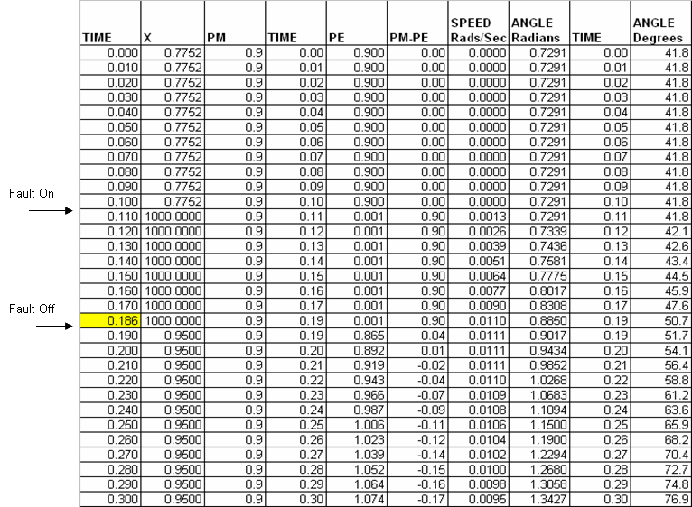

The time is increased in steps of .01 seconds.

There is one exception; the time when the fault is removed can be changed. This is the yellow cell. It must be greater than the preceding time value and less than the following time value.
In the example shown, the fault is applied at 0.1 seconds by increasing the impedance to 1000 per unit. The value increases in the 0.11 cell. The value in the 0.11 cell is used to calculate the acceleration over the interval from 0.1 to 0.11 seconds.
This is the effective transfer impedance between the generator and the infinite bus. It makes the output of the generator go to zero and has the same effect as a terminal fault.
The fault is removed when at the time of .186 seconds.
The fault is on for 0.186 minus 0.1 or .86 seconds.
By changing the time in the yellow cell between the range .181 to .189 we can change the fault clearing time from 0.081 to .089.
The machine parameter can be changed by entering values into the cells shown.

HK | 3.5
PMK | 0.9
DK | 0

After the fault is removed the impedance value is set to .95. This is the equivalent impedance with just the unfaulted line in service.
The system is barely stable as shown by the angle and power curves.

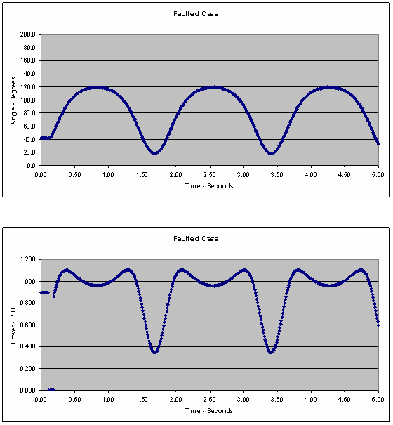

Delayed Fault Clearing

What is the critical fault clearing time for this system?
- 0.86 seconds
- 0.9 seconds
- 0.84 seconds
- 0.1 seconds

Reduced Mechanical Power
What is the critical fault clearing time when the mechanical power is reduced to 0.8 per unit?
- .12 seconds
- .13 seconds
- .14 seconds
- .15 seconds

Delayed Fault Clearing
What is the maximum mechanical power for transient stability if the fault clearing time is delayed to 15 cycles?
- .44 per unit
- .48 per unit
- .54 per unit
- .58 per unit

Line Switching Scenario
You can simulate a simple line switching scenario without any fault by changing the impedance directly from .7752 to .95 as shown.
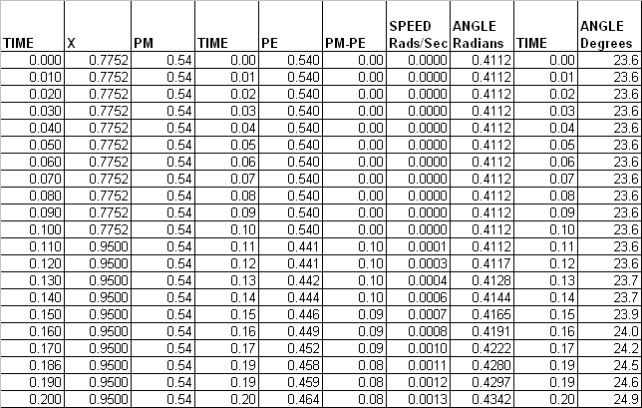

What is the maximum mechanical power for the system to be stable with an un-faulted line switching?
- 1.027 per unit
- 1.032 per unit
- 1.037 per unit
- 1.041 per unit

Damping Scenario
When the mechanical power with the un-faulted line switching scenario is set to 1.02 per unit and the damping factor is set to -0.01 what happens.
- The system is stable
- The system is unstable on the first swing
- The system is unstable on the second swing
- The system is unstable on the third swing

Fault on the Lower Impedance Line
The figure shows the fault applied to the lower impedance line.
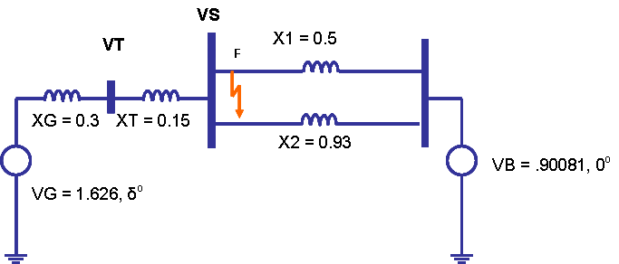

What is the maximum mechanical power to maintain transient stability when a 5 cycle fault is applied to the lower impedance line?
- .44 per unit
- .62 per unit
- .68 per unit
- .74 per unit

Module 6.2 Angle Stability – Energy Functions

Critical Energy Calculation
For this exercise download the Energy Function spread sheet.
The parameters for the Potential Energy worksheet are shown below.

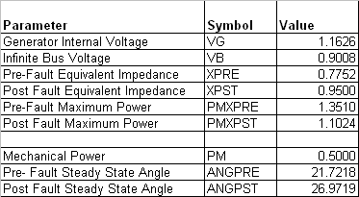

You can calculate the critical energy by entering different values of mechanical power PM.
The Critical Energy is the peak value of the Potential Energy function. This peak occurs in the angle range of 90 to 180 degrees.

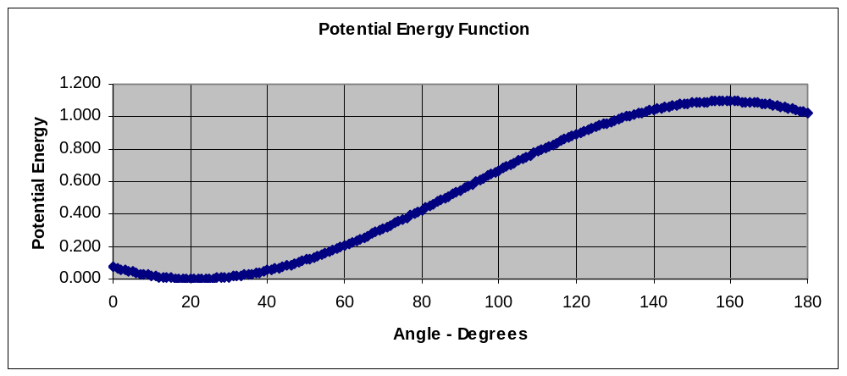

The value of the Critical Energy when the mechanical power is 0.5 per unit is:
- .710
- .805
- .865
- .905

Critical Energy Curve
The Critical Energy Curve is calculated by entering different values of mechanical power and recording the critical energy for each value in the table shown.

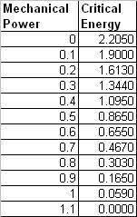

Describe the characteristics of the Critical Energy
- It is the value that occurs when the slope of the potential energy function is zero.
- It occurs at the unstable equilibrium point
- It occurs at an angle in the range of 90 to 180 degrees
- All of the above

Energy Function Worksheet
An example of the Energy Function Worksheet is shown below.

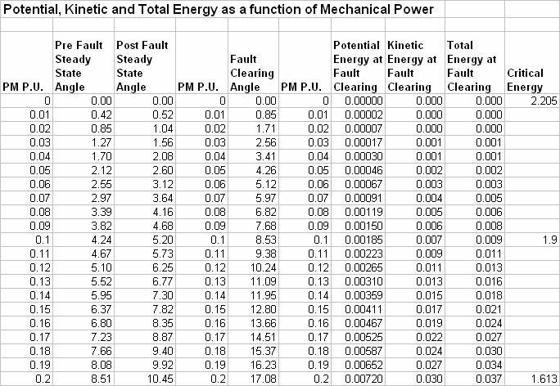

The values of the Critical Energy function were derived by varying the mechanical power in the Potential Energy worksheet.
The various Energy Functions are plotted as shown below.

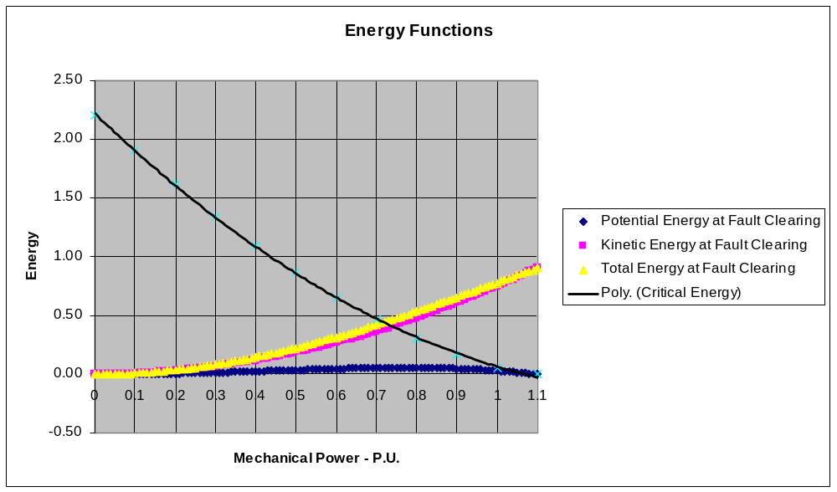

Which of the following statements are true?
- The region above the Critical Energy curve is the stable region
- The region below the Critical Energy curve is the stable region
- The region below the Total Energy Curve is the stable region

Potential Energy at Fault Clearing
The potential energy at fault clearing is calculated by first calculating the angle at fault clearing. This assumes a three phase terminal fault.

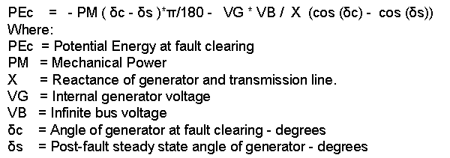
The Kinetic Energy at fault clearing is calculated using the expression.

The Potential Energy at the time of fault clearing is calculated as follows.
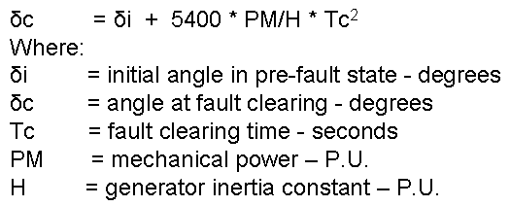

The potential energy at fault clearing is shown as the blue curve in the example with a fault clearing time of 15 cycles.
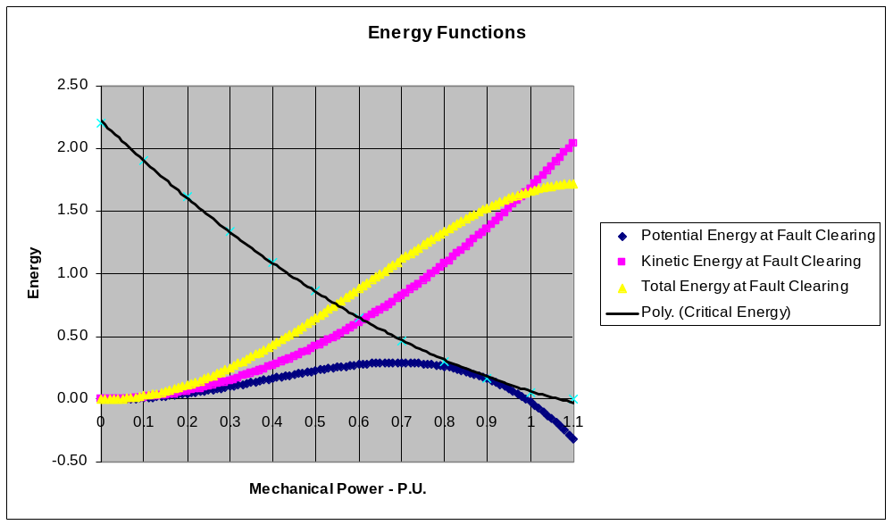

Which of the following statements is not true about the potential energy at fault clearing
- The potential energy at fault clearing may be negative for extended faults
- If the potential energy at fault clearing is negative the system will be stable
- If the system is to be stable the potential energy at fault clearing must be less than the critical energy.

Kinetic Energy at Fault Clearing
The Kinetic Energy at fault clearing is calculated using the following function.

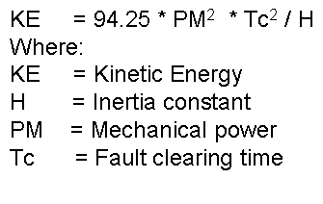

The Kinetic Energy is the pink curve as shown below.

Which statement is not true about the Kinetic Energy at fault clearing when a three phase terminal fault is applied to the generator?
- The Kinetic Energy at fault clearing increases as the square of the fault clearing time.
- The Kinetic Energy at fault clearing increases as the square of the mechanical power.
- The Kinetic Energy at fault clearing increases as the machine inertia constant is increased.
- The Kinetic Energy at fault clearing does not depend on the impedance of the post-fault network.

Maximum Power Calculation
The parameters for the Total Energy Function worksheet are shown below.

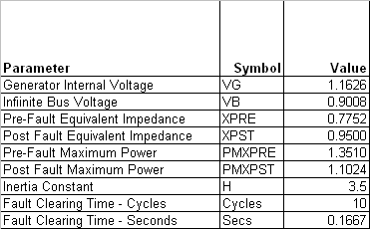

The Inertia Constant and the Fault Clearing time in Cycles can be varied independently and will not affect the Critical Energy Curve.
If any of the other parameters are varied, then the Critical Energy Curve must also be updated.
What is the maximum mechanical power to maintain transient stability when a 10 cycle fault is applied at the generator terminal on the high impedance line and the machine inertia constant is increased from 3.5 to 5.0?
- .7 per unit
- .75 per unit
- .8 per unit
- .85 per unit

Module 6.3 Controlled System Shutdown

Mission

In order to minimize the damage due to a tornado you removed the following stations from service in the order shown:
- Oakdale,
- Nestle,
- Moses,
- Crawford,
- Jenkin,
- Homer.

Operating Instructions and Guides

The scenario involved the shutdown of the two 400 MW gas fired steam units at Crawford and the 600 MW coal fired unit at Homer.

You should manage the amount of load shedding so that the system frequency continually stays above of 59.5 Hertz. You should manage the amount of generation shedding so that the system frequency continually stays below 61.0 Hertz.

You should aim to keep the bus voltages within a band of plus and minus 10%. Please record any voltage violations beyond this range.

Scoring of Your Solution

After each substation has been removed from service please record the following values:
- System Load
- Highest MVA overload
- Highest Bus Voltage
- Lowest bus voltage
- Highest system frequency deviation since the last station was cleared.
- Lowest system frequency deviation since the last station was cleared.

Initialization
You loaded the Noon case and started the PowerSimulator and proceeded to:

Remove Oakdale Station

Remove Nestle Station

Remove Moses Station

Remove Crawford Station

Remove Jenkin Station

Remove Homer Station

Final Step
Enter the points that you scored for each station into the following table and calculate the total.

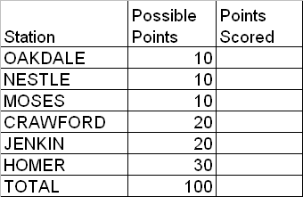

At each milestone the points awarded will be deducted by 20% if any voltages have varied outside of a plus or minus 10% band since the last milestone.

At each milestone the points awarded will be deducted by 20% if any bus frequencies have varied outside of a 59.5 to 61 HZ band since the last milestone

